The Second Sunday after the Epiphany

Year A & Daily Office Year One
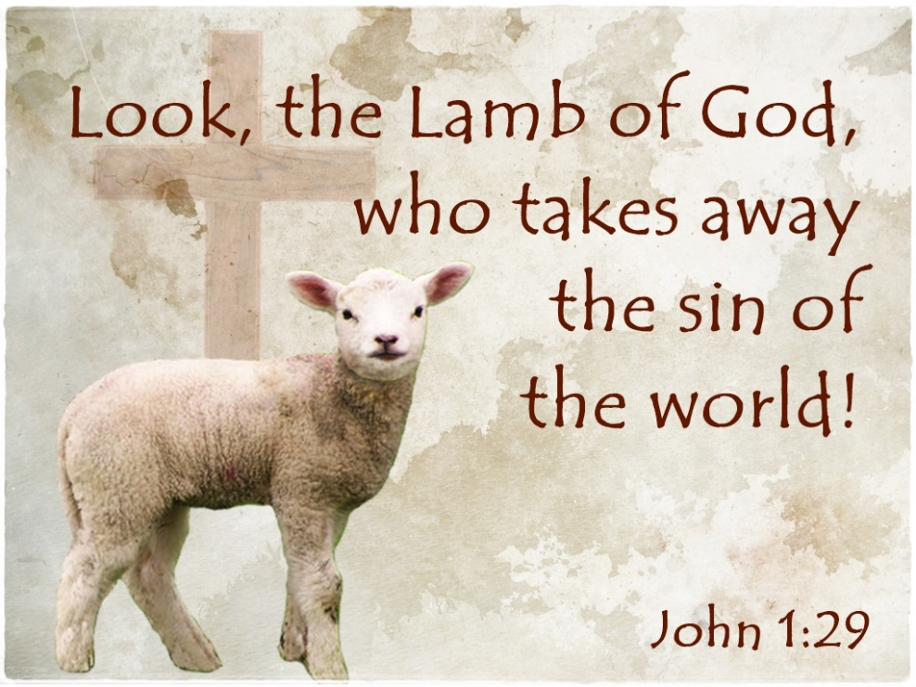

Sunday January 15, 2023
St. Matthew’s Episcopal Church
Fairbanks, AK

The Word of God

Entrance Rite

Entrance Hymn “hail to the lord’s anointed”

Opening Acclamation

Collect for Purity
Almighty God, to you all hearts are open, all desires known, and from you no secrets are hid: Cleanse the thoughts of our hearts by the inspiration of your Holy Spirit, that we may perfectly love you, and worthily magnify your holy Name; through Christ our Lord. Amen.

The gloria
Glory to God in the highest,
and peace to his people on earth.
Lord God, heavenly King,
almighty God and Father,
we worship you, we give you thanks,
we praise you for your glory.
Lord Jesus Christ, only Son of the Father,
Lord God, Lamb of God,
you take away the sin of the world:
have mercy on us;
you are seated at the right hand of the Father:
receive our prayer.
For you alone are the Holy One,
you alone are the Lord,
you alone are the Most High,
Jesus Christ,
with the Holy Spirit,
in the glory of God the Father. Amen.

The Collect of the Day
Celebrant | The Lord be with you.
People | And also with you.
Celebrant | Let us pray.

Almighty God, whose Son our Savior Jesus Christ is the light of the world: Grant that your people, illumined by your Word and Sacraments, may shine with the radiance of Christ’s glory, that he may be known, worshiped, and obeyed to the ends of the earth; through Jesus Christ our Lord, who with you and the Holy Spirit lives and reigns, one God, now and for ever. Amen.

The Lessons

First Reading: Isaiah 49:1-7
A Reading from the book of the prophet Isaiah.
¹Listen to me, O coastlands,
pay attention, you peoples from far away!
The Lord called me before I was born,
while I was in my mother’s womb he named me.
²He made my mouth like a sharp sword,
in the shadow of his hand he hid me;
he made me a polished arrow,
in his quiver he hid me away.
³And he said to me, “You are my servant,
Israel, in whom I will be glorified.”
⁴But I said, “I have labored in vain,
I have spent my strength for nothing and vanity;
yet surely my cause is with the Lord,
and my reward with my God.”
⁵And now the Lord says,
who formed me in the womb to be his servant,
to bring Jacob back to him,
and that Israel might be gathered to him,
for I am honored in the sight of the Lord,
and my God has become my strength—
⁶he says,
“It is too light a thing that you should be my servant
to raise up the tribes of Jacob
and to restore the survivors of Israel;
I will give you as a light to the nations,
that my salvation may reach to the end of the earth.”
⁷Thus says the Lord,
the Redeemer of Israel and his Holy One,
to one deeply despised, abhorred by the nations,
the slave of rulers,
“Kings shall see and stand up,
princes, and they shall prostrate themselves,
because of the Lord, who is faithful,
the Holy One of Israel, who has chosen you.”

Reader | The Word of the Lord.
People | Thanks be to God.

Psalm: Psalm 40:1-12
¹I waited patiently upon the Lord; *
he stooped to me and heard my cry.
²He lifted me out of the desolate pit, out of the mire and clay; *
he set my feet upon a high cliff and made my footing sure.
³He put a new song in my mouth,
a song of praise to our God; *
many shall see, and stand in awe,
and put their trust in the Lord.
⁴Happy are they who trust in the Lord! *
they do not resort to evil spirits or turn to false gods.
⁵Great things are they that you have done, O Lord my God!
how great your wonders and your plans for us! *
there is none who can be compared with you.
⁶Oh, that I could make them known and tell them! *
but they are more than I can count.
⁷In sacrifice and offering you take no pleasure; *
(you have given me ears to hear you);
⁸Burnt-offering and sin-offering you have not required, *
and so I said, “Behold, I come.
⁹In the roll of the book it is written concerning me: *
‘I love to do your will, O my God;
your law is deep in my heart.’ ”
¹⁰I proclaimed righteousness in the great congregation; *
behold, I did not restrain my lips;
and that, O Lord, you know.
¹¹Your righteousness have I not hidden in my heart;
I have spoken of your faithfulness and your deliverance; *
I have not concealed your love and faithfulness from the great congregation.
¹²You are the Lord;
do not withhold your compassion from me; *
let your love and your faithfulness keep me safe for ever.

Second Reading: 1 Corinthians 1:1-9
A Reading from Paul's First letter to the Church in Corinth.
¹Paul, called to be an apostle of Christ Jesus by the will of God, and our brother Sosthenes,
²To the church of God that is in Corinth, to those who are sanctified in Christ Jesus, called to be saints, together with all those who in every place call on the name of our Lord Jesus Christ, both their Lord and ours:
³Grace to you and peace from God our Father and the Lord Jesus Christ.
⁴I give thanks to my God always for you because of the grace of God that has been given you in Christ Jesus, ⁵for in every way you have been enriched in him, in speech and knowledge of every kind—⁶just as the testimony of Christ has been strengthened among you—⁷so that you are not lacking in any spiritual gift as you wait for the revealing of our Lord Jesus Christ. ⁸He will also strengthen you to the end, so that you may be blameless on the day of our Lord Jesus Christ. ⁹God is faithful; by him you were called into the fellowship of his Son, Jesus Christ our Lord.

Reader | The Word of the Lord.
People | Thanks be to God.

Gospel: John 1:29-42
Priest | The Holy Gospel of our Lord Jesus Christ according to John.
People | Glory to you, Lord Christ.

²⁹[John] saw Jesus coming toward him and declared, “Here is the Lamb of God who takes away the sin of the world!³⁰This is he of whom I said, ‘After me comes a man who ranks ahead of me because he was before me.’ ³¹I myself did not know him; but I came baptizing with water for this reason, that he might be revealed to Israel.” ³²And John testified, “I saw the Spirit descending from heaven like a dove, and it remained on him. ³³I myself did not know him, but the one who sent me to baptize with water said to me, ‘He on whom you see the Spirit descend and remain is the one who baptizes with the Holy Spirit.’ ³⁴And I myself have seen and have testified that this is the Son of God.”
³⁵The next day John again was standing with two of his disciples, ³⁶and as he watched Jesus walk by, he exclaimed, “Look, here is the Lamb of God!” ³⁷The two disciples heard him say this, and they followed Jesus. ³⁸When Jesus turned and saw them following, he said to them, “What are you looking for?” They said to him, “Rabbi” (which translated means Teacher), “where are you staying?” ³⁹He said to them, “Come and see.” They came and saw where he was staying, and they remained with him that day. It was about four o’clock in the afternoon. ⁴⁰One of the two who heard John speak and followed him was Andrew, Simon Peter’s brother. ⁴¹He first found his brother Simon and said to him, “We have found the Messiah” (which is translated Anointed). ⁴²He brought Simon to Jesus, who looked at him and said, “You are Simon son of John. You are to be called Cephas” (which is translated Peter).

Priest | The Gospel of the Lord.
People | Praise to you, Lord Christ.

The Homily - The Rev. Susan Mitchell

The Creed
We believe in one God,
the Father, the Almighty,
maker of heaven and earth,
of all that is, seen and unseen.
We believe in one Lord, Jesus Christ,
the only Son of God,
eternally begotten of the Father,
God from God, Light from Light,
true God from true God,
begotten, not made,
of one Being with the Father.
Through him all things were made.
For us and for our salvation
he came down from heaven:
by the power of the Holy Spirit
he became incarnate from the Virgin Mary,
and was made man.
For our sake he was crucified under Pontius Pilate;
he suffered death and was buried.
On the third day he rose again
in accordance with the Scriptures;
he ascended into heaven
and is seated at the right hand of the Father.
He will come again in glory to judge the living and the dead,
and his kingdom will have no end.
We believe in the Holy Spirit, the Lord, the giver of life,
who proceeds from the Father and the Son.
With the Father and the Son he is worshiped and glorified.
He has spoken through the Prophets.
We believe in one holy catholic and apostolic Church.
We acknowledge one baptism for the forgiveness of sins.
We look for the resurrection of the dead,
and the life of the world to come. Amen.

The Prayers of the People
All remain standing.
With all our heart and with all our mind, let us pray to the Lord, saying, “Lord, have mercy.”
[For the peace from above, for the loving kindness of God, and for the salvation of our souls, let us pray to the Lord.
Lord, have mercy.]
For the peace of the world, for the welfare of the holy Church of God, and for the unity of all peoples, let us pray to the Lord.
Lord, have mercy.
For our Bishop, and for all the clergy and people, let us pray to the Lord.
Lord, have mercy.
For our President, for the leaders of the nations, and for all in authority, let us pray to the Lord.
Lord, have mercy.
For this city (town, village, ___________ ), for every city and community, and for those who live in them, let us pray to the Lord.
Lord, have mercy.
[For seasonable weather, and for an abundance of the fruits of the earth, let us pray to the Lord.
Lord, have mercy.]
For the good earth which God has given us, and for the wisdom and will to conserve it, let us pray to the Lord.
Lord, have mercy.
[For those who travel on land, on water, or in the air [or through outer space], let us pray to the Lord.
Lord, have mercy.]
For the aged and infirm, for the widowed and orphans, and for the sick and the suffering, let us pray to the Lord.
Lord, have mercy.
[For ___________ , let us pray to the Lord.
Lord, have mercy.]
For the poor and the oppressed, for the unemployed and the destitute, for prisoners and captives, and for all who remember and care for them, let us pray to the Lord.
Lord, have mercy.
For all who have died in the hope of the resurrection, and for all the departed, let us pray to the Lord.
Lord, have mercy.
For deliverance from all danger, violence, oppression, and degradation, let us pray to the Lord.
Lord, have mercy.
[For the absolution and remission of our sins and offenses, let us pray to the Lord.
Lord, have mercy.]
That we may end our lives in faith and hope, without suffering and without reproach, let us pray to the Lord.
Lord, have mercy.
[Defend us, deliver us, and in thy compassion protect us, O Lord, by thy grace.
Lord, have mercy.]
In the communion of [ ___________ and of all the] saints, let us commend ourselves, and one another, and all our life, to Christ our God.
To thee, O Lord our God.
Silence
The Celebrant adds a concluding Collect.

Confession of Sin

Let us confess our sins against God and our neighbor.
Most merciful God,
we confess that we have sinned against you
in thought, word, and deed,
by what we have done,
and by what we have left undone.
We have not loved you with our whole heart;
we have not loved our neighbors as ourselves.
We are truly sorry and we humbly repent.
For the sake of your Son Jesus Christ,
have mercy on us and forgive us;
that we may delight in your will,
and walk in your ways,
to the glory of your Name. Amen.
Almighty God have mercy on you, forgive you all your sins through our Lord Jesus Christ, strengthen you in all goodness, and by the power of the Holy Spirit keep you in eternal life. Amen.

The Peace
Celebrant | The peace of the Lord be always with you.
People | And also with you.

The Holy Communion

Offertory Sentence
Offer to God a sacrifice of thanksgiving, and make good your vows to the Most High. Psalm 50:14

Offertory Hymn “jesus call us”

The Great Thanksgiving

Celebrant | The Lord be with you.
People | And also with you.
Celebrant | Lift up your hearts.
People | We lift them to the Lord.
Celebrant | Let us give thanks to the Lord our God.
People | It is right to give him thanks and praise.

It is right, and a good and joyful thing, always and everywhere to give thanks to you, Father Almighty, Creator of heaven and earth.
Because in the mystery of the Word made flesh, you have caused a new light to shine in our hearts, to give the knowledge of your glory in the face of your Son Jesus Christ our Lord.
Therefore we praise you, joining our voices with Angels and Archangels and with all the company of heaven, who for ever sing this hymn to proclaim the glory of your Name:

Holy, holy, holy Lord, God of power and might,
heaven and earth are full of your glory.
Hosanna in the highest.
Blessed is he who comes in the name of the Lord.
Hosanna in the highest.

Holy and gracious Father: In your infinite love you made us for yourself; and, when we had fallen into sin and become subject to evil and death, you, in your mercy, sent Jesus Christ, your only and eternal Son, to share our human nature, to live and die as one of us, to reconcile us to you, the God and Father of all.
He stretched out his arms upon the cross, and offered himself in obedience to your will, a perfect sacrifice for the whole world.
On the night he was handed over to suffering and death, our Lord Jesus Christ took bread; and when he had given thanks to you, he broke it, and gave it to his disciples, and said, “Take, eat: This is my Body, which is given for you. Do this for the remembrance of me.”
After supper he took the cup of wine; and when he had given thanks, he gave it to them, and said, “Drink this, all of you: This is my Blood of the new Covenant, which is shed for you and for many for the forgiveness of sins. Whenever you drink it, do this for the remembrance of me.”
Therefore we proclaim the mystery of faith:
Christ has died.
Christ is risen.
Christ will come again.

We celebrate the memorial of our redemption, O Father, in this sacrifice of praise and thanksgiving. Recalling his death, resurrection, and ascension, we offer you these gifts.
Sanctify them by your Holy Spirit to be for your people the Body and Blood of your Son, the holy food and drink of new and unending life in him. Sanctify us also that we may faithfully receive this holy Sacrament, and serve you in unity, constancy, and peace; and at the last day bring us with all your saints into the joy of your eternal kingdom.
All this we ask through your Son Jesus Christ. By him, and with him, and in him, in the unity of the Holy Spirit all honor and glory is yours, Almighty Father, now and for ever. AMEN.

The Lord’s Prayer
And now, as our Savior Christ has taught us, we are bold to say,
Our Father, who art in heaven,
hallowed be thy Name,
thy kingdom come,
thy will be done, on earth as it is in heaven.
Give us this day our daily bread.
And forgive us our trespasses,
as we forgive those who trespass against us.
And lead us not into temptation,
but deliver us from evil.
For thine is the kingdom,
and the power, and the glory,
forever and ever. Amen.

The Breaking of the Bread

Alleluia. Christ our Passover is sacrificed for us;
Therefore let us keep the feast. Alleluia.

The Gifts of God for the People of God. Take them in remembrance that Christ died for you, and feed on him in your hearts by faith, with thanksgiving.

Communion Hymn

Post-Communion Prayer
Let us pray.
Eternal God, heavenly Father,
you have graciously accepted us as living members
of your Son our Savior Jesus Christ,
and you have fed us with spiritual food
in the Sacrament of his Body and Blood.
Send us now into the world in peace,
and grant us strength and courage
to love and serve you
with gladness and singleness of heart;
through Christ our Lord. Amen.

Blessing

Post-Communion Hymn “what wondrous love is this?”

Dismissal
 | Let us go forth in the name of Christ.
People | Thanks be to God.

From riteplanning.com.
Copyright © 2023 Church Publishing Inc. All rights reserved.

